Federal Education Spending and State-Level Investment Patterns:
2000 - 2022

Nina Ysabel Alinsonorin
IST 686: Quantitative Reasoning

Table of Contents

- Motivation
- Data Sourcing
- Exploratory Data Analysis
- Analytic Models
  - Frequentist Model
  - Bayesian Model
  - Fixed-Effects Model
- Results Summary
- Limitations/Next Steps
- Appendix

- Motivation
Education funding is a central policy mechanism through which the federal government seeks to promote equity across U.S. states. Federal education dollars are intended to supplement state and local revenues, particularly in lower-wealth jurisdictions, with the goal of reducing disparities in educational opportunity. However, a recurring empirical finding in national education finance reports (most notably those published by the National Center for Education Statistics (NCES)) is that states with higher reliance on federal funding often exhibit lower total per-student spending overall.
This project replicates and extends NCES state-level finance analyses to evaluate whether this pattern can be reproduced using publicly available NCES data. Rather than treating federal funding as a causal determinant of education investment, the analysis investigates whether federal funding share serves as a statistical indicator of broader structural fiscal inequality across states.

The central research questions guiding this study are:
- Is a higher federal share of education revenue associated with lower total per-student spending at the state level?
- Does this relationship persist across frequentist, Bayesian, and panel-data modeling frameworks?
How should this relationship be interpreted in the context of structural differences across states?
By explicitly reproducing and validating NCES-style results, this project aims to demonstrate the robustness of these findings while situating them within a rigorous inferential framework.

II. Data Sourcing and Exploratory Analysis
Data Collection
The data used in this study were obtained from the National Center for Education Statistics (NCES) State School Finance (STFIS) files, which provide annual, state-level fiscal data on public elementary and secondary education in the United States. These files are publicly available and widely used in federal education finance reporting, including NCES’s own Condition of Education and Digest of Education Statistics publications.
The STFIS dataset consists of separate annual files, each corresponding to a single fiscal year. For this project, files covering the years 2000 through 2022 were downloaded individually from the NCES website. Each file contains detailed information on education revenues disaggregated by funding source, as well as student enrollment counts. Because the files were produced across multiple years, they vary in formatting, variable naming conventions, and data encoding practices. The unit of analysis is the state–year, resulting in a longitudinal dataset that tracks education finance measures for U.S. states, the District of Columbia, and selected U.S. territories over time. This structure produces an unbalanced panel, as not all states or territories appear in every year.
NCES data are generally considered high quality due to standardized reporting requirements and federal oversight. However, the decentralized nature of state reporting and the long time span of the data necessitate careful preprocessing to ensure consistency and comparability across years.

Data Cleaning and Processing
Significant data cleaning and harmonization were required prior to analysis. The raw STFIS files differed in column naming conventions, data types, and numeric formatting across years. To address these issues, all files were read into R as character data and standardized using a consistent workflow.
First, each annual file was imported and cleaned using uniform variable naming. The year variable was extracted directly from the filename to ensure consistency across files and avoid reliance on inconsistently labeled year columns. All files were then merged into a single dataset containing all state-year observations. From the merged dataset, only the core variables relevant to the research question were retained: year, state name, state FIPS code, total education revenue, federal education revenue, and student enrollment. These variables form the foundation of NCES education finance analyses and are directly comparable across years.
Many revenue and enrollment fields contained commas or other non-numeric characters, which prevented direct numeric conversion. These characters were removed programmatically, after which all financial and enrollment variables were converted to numeric form. Observations with missing values, zero enrollment, or zero total revenue were excluded to avoid invalid per-capita calculations and division-by-zero errors. Total and federal revenues were divided by student enrollment to create per-student spending measures, and federal share was calculated as the proportion of total revenue originating from federal sources. These transformations allow for meaningful comparisons across states of vastly different population sizes.
Additional preprocessing steps were taken to standardize state identifiers. Inconsistent state name spellings and formatting differences (such as multiple representations of the District of Columbia and certain U.S. territories) were corrected to ensure accurate grouping and aggregation. Whitespace was trimmed and known naming inconsistencies were harmonized.
Finally, per-capita measures were rescaled into thousands of dollars to improve interpretability and numerical stability in regression models. The resulting analysis dataset contains clean, standardized, and comparable state-year observations suitable for descriptive exploration, regression modeling, and panel-data analysis. Overall, the data collection and preprocessing steps ensure that the final dataset closely mirrors the structure and quality of NCES’s own analytic datasets, allowing for a valid replication and extension of published NCES findings.

III. Exploratory Data Analysis
Exploratory data analysis was conducted to understand the distribution, trends, and relationships among key education finance variables prior to formal modeling. The EDA focused on three primary goals: (1) examining how per-student education spending varies across states, (2) identifying national trends over time, and (3) exploring the relationship between federal funding reliance and total education spending. These exploratory findings directly informed the choice of inferential models used in subsequent analysis.
Cross-State Variation in Per-Student Spending
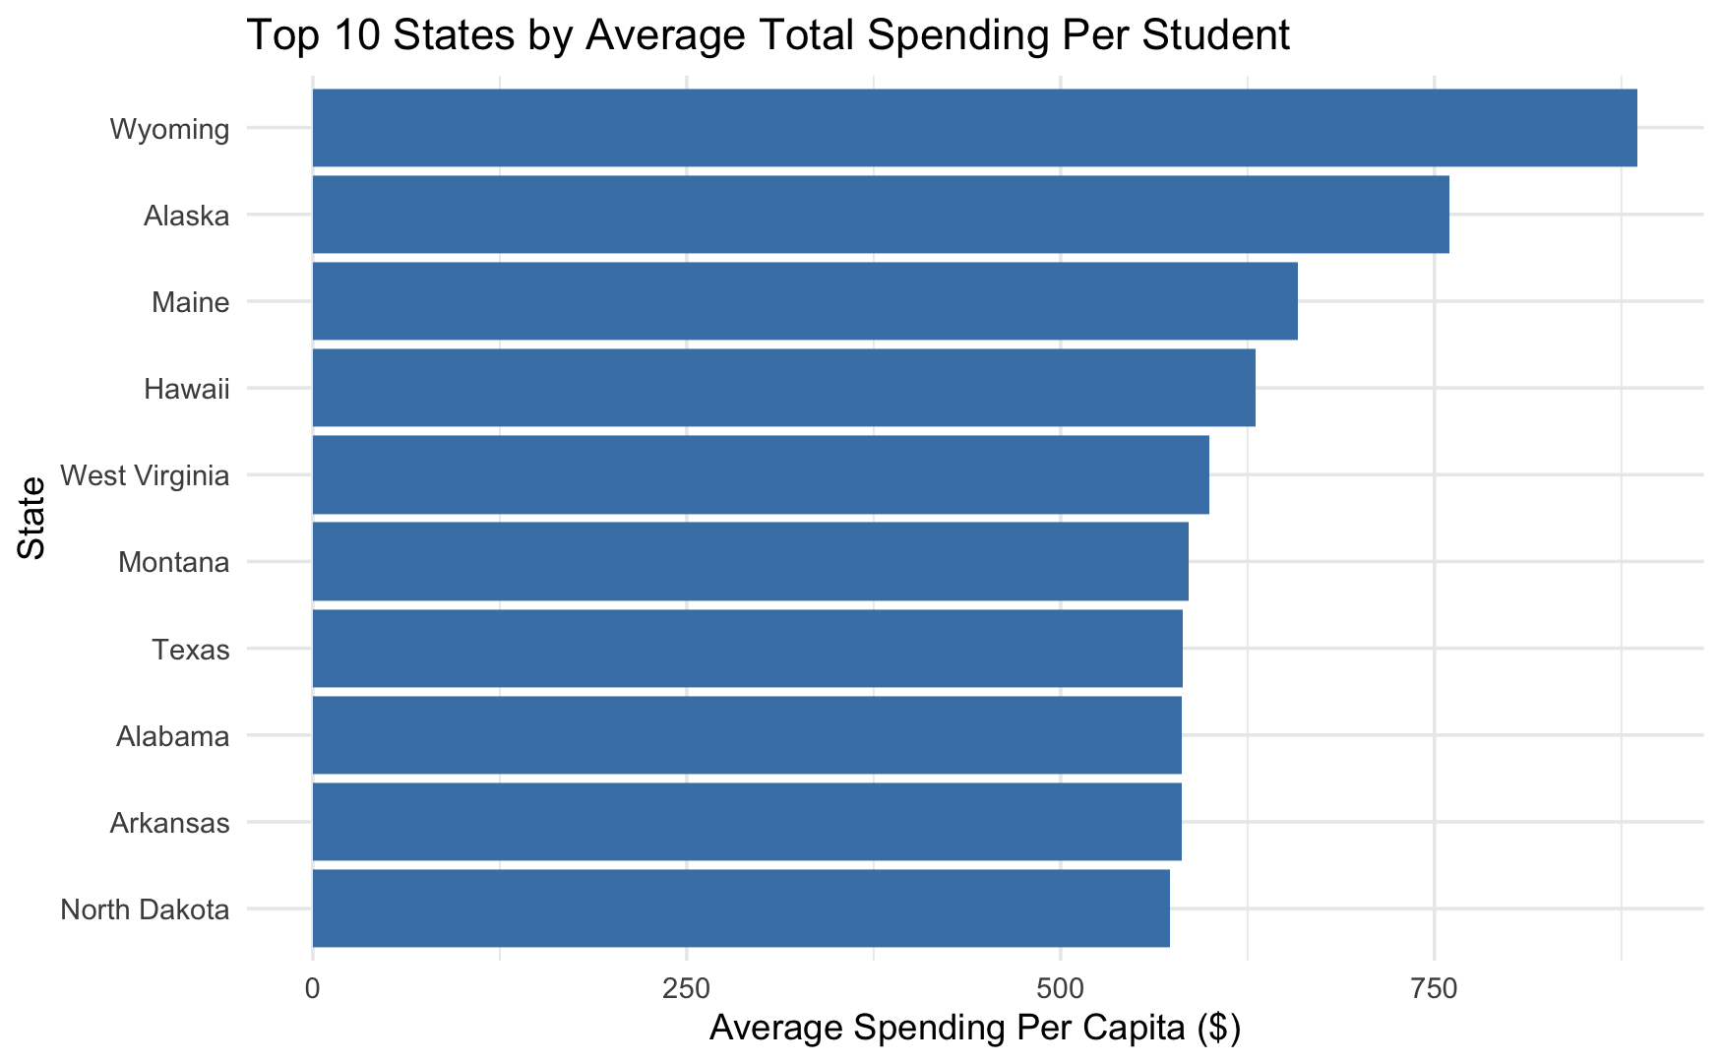
Figure 1. Top 10 States by Average Total Spending per Student
Figure 1 presents a bar chart of the top ten states by average total per-student education spending over the study period. Substantial variation across states is evident. States such as Wyoming, Alaska, and the District of Columbia consistently exhibit much higher per-student spending than most other states. These differences reflect well-documented structural factors, including small student populations, geographic cost differences, and reliance on non-education revenue sources (e.g., energy extraction revenues).
Importantly, the figure highlights that high per-student spending does not correspond directly to high federal funding shares. For example, several high-spending states receive a relatively small proportion of their total education revenue from federal sources. This observation suggests that federal funding plays a compensatory role rather than serving as the primary driver of overall education investment. This cross-state heterogeneity reinforces the importance of scaling spending measures by enrollment and cautions against interpreting total revenue figures without accounting for population size.

National Trends in Per-Student Spending Over Time
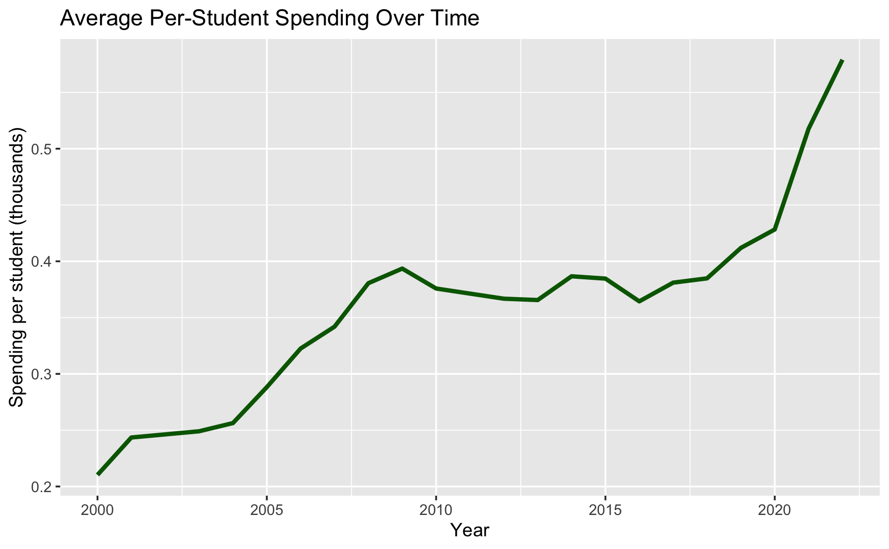
Figure 2. Average Per-Student Spending Over Time
Figure 2 displays the national average of per-student total education spending over time, calculated as the mean across states for each year. The trend shows a gradual increase in per-student spending over the early 2000s, followed by periods of stagnation and modest decline, particularly around major economic disruptions such as the Great Recession and the COVID-19 pandemic.
While overall spending levels increase slightly in nominal terms, the trend is notably flatter once adjusted on a per-student basis. This suggests that growth in education spending has not consistently outpaced enrollment changes or broader fiscal pressures over time. The relatively muted time trend motivates the inclusion of a year variable in the regression models to capture temporal effects that might otherwise confound the relationship between funding structure and spending levels.

Relationship Between Federal Share and Total Per-Student Spending
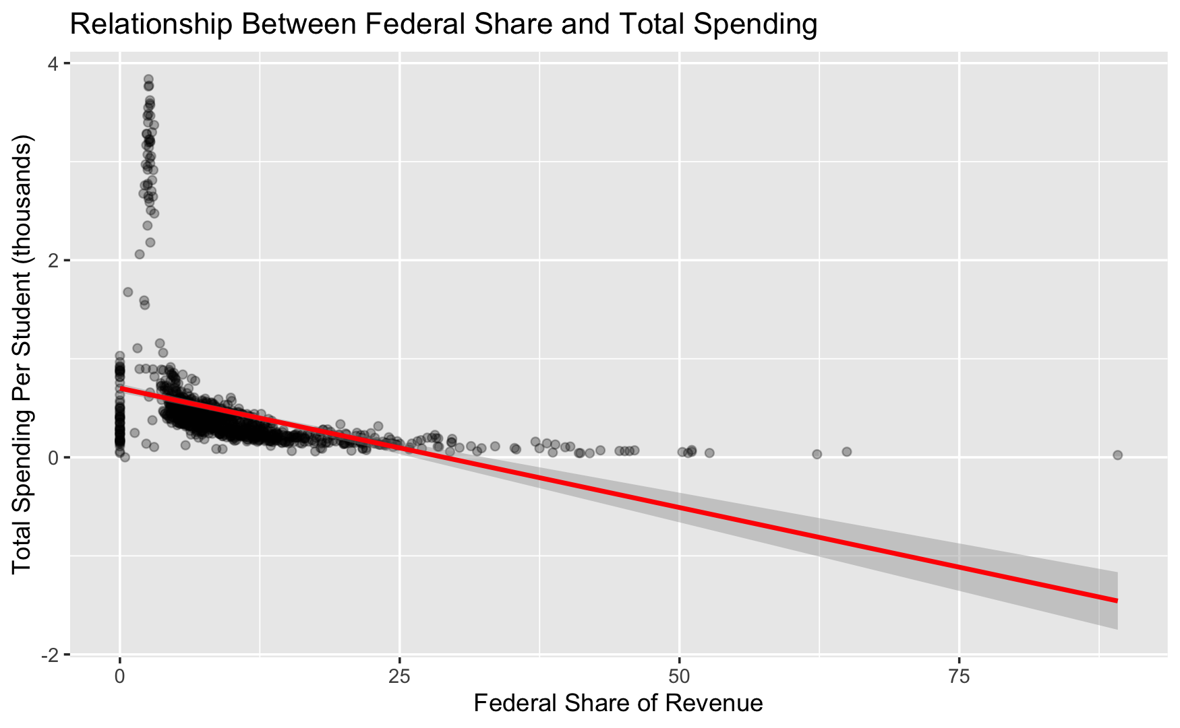
Figure 3. Relationship Between Federal Share and Total Spending
Figure 3 presents a scatterplot of federal share of education revenue versus total per-student spending, with a fitted linear trend. The plot reveals a clear negative association: states with higher reliance on federal funding tend to exhibit lower total per-student spending. Most observations cluster at low federal share values (below 10%), where total spending varies widely. However, as federal share increases beyond this range, total per-student spending consistently declines. This pattern suggests that federal funding is concentrated in states with limited state and local revenue capacity, rather than acting as a mechanism that raises overall spending levels.
The fitted regression line reinforces this visual pattern and provides initial evidence that higher federal reliance is associated with lower total spending per student. These findings are consistent with federal education finance policy, which targets funding toward higher-need states and districts rather than equalizing total spending across states.

Implications for Model Selection
Taken together, the exploratory analyses reveal three key features of the data: substantial cross-state heterogeneity, modest time trends, and a consistent negative association between federal funding share and total per-student spending. These findings justify the use of both frequentist and Bayesian regression models to estimate average relationships, as well as panel fixed-effects models to control for unobserved state-level characteristics. The EDA confirms that simple descriptive comparisons are insufficient to explain education spending patterns and motivates the inferential modeling approaches used in subsequent sections.

IV. Analytic Models
The goal of this analysis is to assess whether differences in federal reliance in education funding are associated with differences in total per-student education spending across U.S. states over time. Because the dataset consists of repeated observations for each state across multiple years, the analysis proceeds in stages, beginning with pooled regression approaches and culminating in a panel fixed-effects model. This progression allows increasingly strong control over confounding factors while maintaining interpretability. All models treat total per-student spending (in thousands of dollars) as the outcome variable and focus on the role of federal share of education revenue as the primary explanatory variable.

Frequentist Analysis
Frequentist linear regression models were first used to estimate the average association between federal funding reliance and total per-student spending across all states and years. These models treat the dataset as a pooled cross-section, implicitly assuming that each observation is independent and that unobserved differences across states are captured in the error term. Although this assumption is imperfect for panel data, these models provide a clear baseline estimate that is easy to interpret and comparable to many policy analyses.

Model 1: Federal Share Only
The simplest model estimates:
Total Spending_{it} = 𝛽₀ + 𝛽₁(FederalShare_{it}) + 𝜀_{it}
This specification asks a direct descriptive question: Do states that rely more heavily on federal funding tend to spend more or less per student overall? The estimated coefficient on federal share is negative and statistically significant, indicating that higher federal reliance is associated with lower total per-student spending. Because the outcome variable is measured in thousands of dollars, the coefficient can be interpreted as the dollar change in per-student spending associated with a one-unit increase in federal share. However, this model does not account for broader time trends or persistent differences across states.
Model 2: Federal Share with Time Control
To account for national trends in education spending over time, a second frequentist model adds a linear year term:

Total Spending_{it} = 𝛽₀ + 𝛽₁(FederalShare_{it}) + 𝛽₂(Year_{t}) + 𝜀_{it}

Including year controls for inflation-adjusted secular changes, macroeconomic conditions, and national policy shifts that affect all states simultaneously. This allows the coefficient on federal share to be interpreted as the association with spending holding constant national time trends. The results show that the negative association between federal share and total spending persists even after controlling for time, indicating that the observed relationship is not driven solely by temporal trends.

Bayesian Linear Regression
A Bayesian regression model was estimated using the same specification as the frequentist time-controlled model. Bayesian analysis provides a complementary inferential framework by estimating posterior distributions for each parameter rather than relying on point estimates and p-values. This approach allows uncertainty to be expressed probabilistically and avoids reliance on asymptotic assumptions.

The Bayesian model assumes:

Total Spending_{it} ~ N(μ_{it}, 𝝈²)
μ_{it} = 𝛽₀ + 𝛽₁(FederalShare_{it}) + 𝛽₂(Year_{t})

Diffuse priors were placed on all regression coefficients, allowing the data to dominate the posterior distributions.

Posterior means for federal share and year closely match the frequentist estimates, providing strong confirmation of the robustness of the results across inferential frameworks. The 95% credible intervals for both coefficients exclude zero, indicating high posterior probability that these effects are non-zero. The narrow posterior distributions reflect strong certainty in the direction and magnitude of the estimated relationships. Trace plots and density plots indicate good mixing and convergence of the Markov chains, supporting the reliability of the posterior estimates. The Bayesian results reinforce the frequentist findings while offering a more intuitive interpretation: given the data, there is overwhelming probability that higher federal funding reliance is associated with lower total per-student spending.

Panel Fixed-Effects Model
While pooled regressions estimate average relationships, they do not account for unobserved, time-invariant differences across states, such as governance structures, tax capacity, cost of living, or political priorities. Because these factors are likely correlated with both spending levels and federal reliance, omitting them can bias estimates. To address this, a fixed-effects panel model was estimated.

The fixed-effects model takes the form:
Total Spending_{it} = 𝛽₁(FederalShare_{it}) +𝛾_{t} + 𝛼_{i} + 𝜀_{it}

Where:
- 𝛼_{i} captures state-specific fixed effects
- 𝛾_{t} captures year effects
- Identification comes from within-state changes over time

This model asks a stricter question: when a given state becomes more or less reliant on federal funding over time, does its total per-student spending change accordingly?

Relationship Between Models
Taken together, the model sequence demonstrates a consistent and robust pattern:
- Frequentist models estimate average cross-state associations.
- Bayesian models confirm these associations probabilistically.
- Fixed-effects models show that the relationship persists even when controlling for unobserved state characteristics.

V. Results Summary
Frequentist Regression Results
A multiple linear regression model was estimated to examine the relationship between total per-student spending and federal revenue share while controlling for time trends. The results indicate a statistically significant negative association between federal share and total per-student spending.
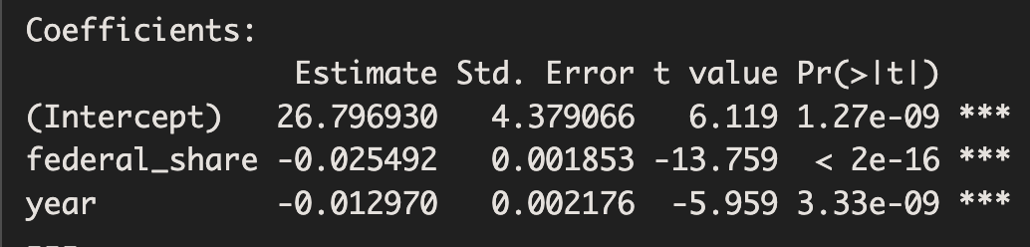
Figure 4. Regression Coefficients
Specifically, the estimated coefficient on federal share was −0.0255 (p < 2 × 10⁻¹⁶), indicating that a one-percentage-point increase in the share of revenue coming from federal sources is associated with an average decrease of approximately $25 per student in total spending (measured in thousands). The year coefficient was also negative (−0.0130, p < 0.001), suggesting a modest downward trend in inflation-adjusted per-student spending over the study period when holding federal share constant.
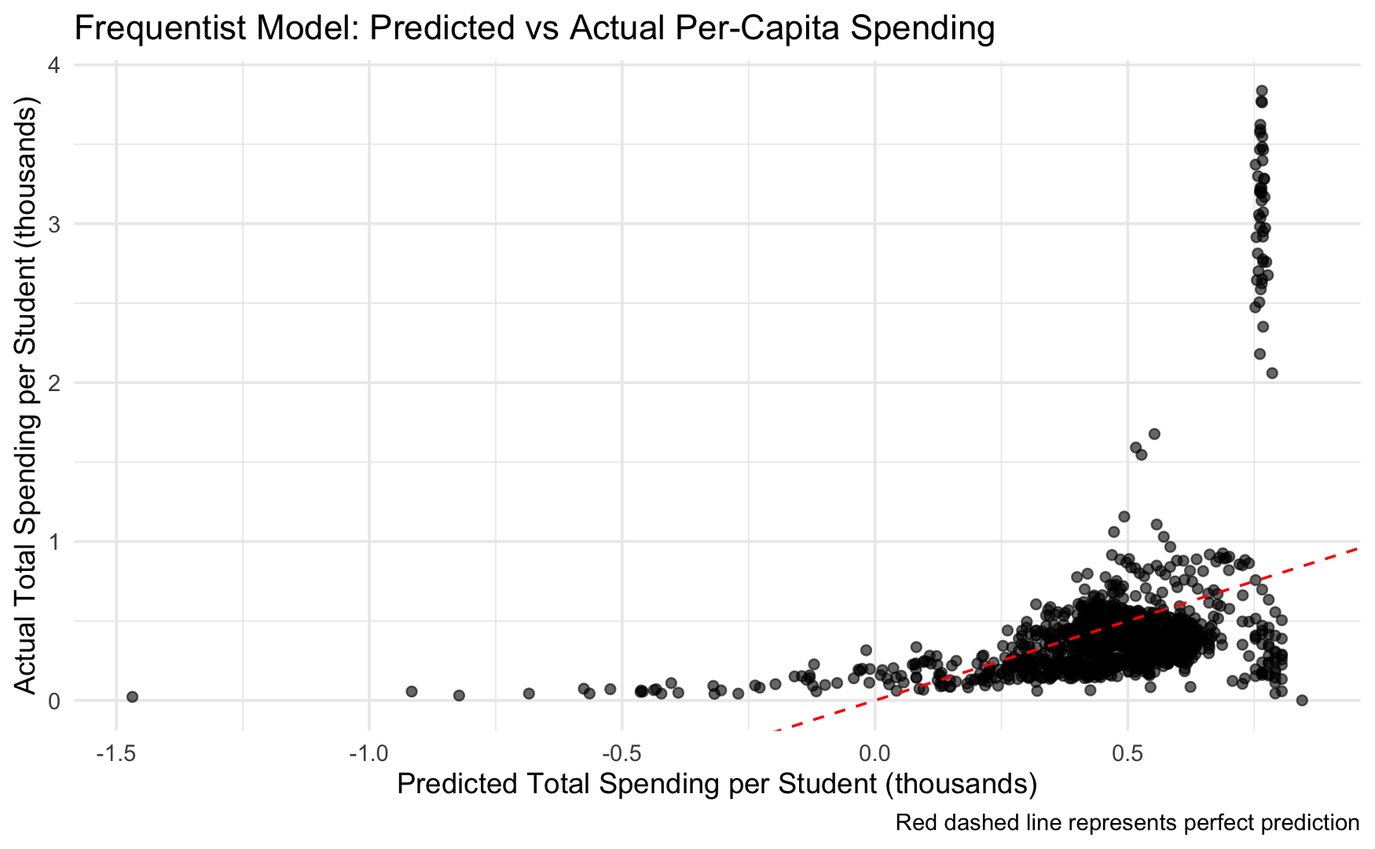
Figure 5. Predicted vs. Actual Spending
The model explains approximately 14.9% of the variation in per-student spending (R² = 0.1486). Diagnostic plots revealed heteroskedasticity and non-normal residuals, consistent with the presence of structural differences across states that are not fully captured by this pooled regression specification. These findings motivated the use of alternative modeling approaches.

Bayesian Regression Results
A Bayesian linear regression model with the same specification was estimated to assess the robustness of the frequentist findings. Posterior estimates closely aligned with the frequentist results.
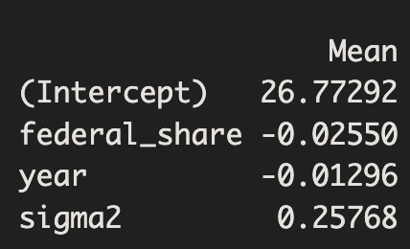
Figure 6.
The posterior mean for federal share was −0.0255, with a 95% credible interval of [−0.0290, −0.0219], which excludes zero. This provides strong Bayesian evidence that higher reliance on federal funding is credibly associated with lower total per-student spending. The year coefficient similarly exhibited a negative posterior mean (−0.0130), with a 95% credible interval of [−0.0172, −0.0088], reinforcing the presence of a modest downward time trend.
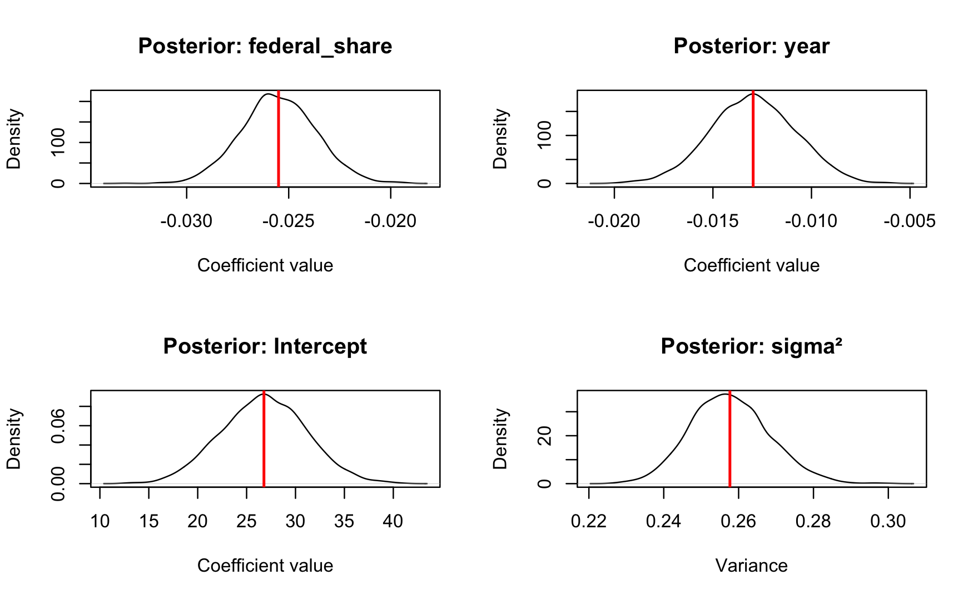
Figure 7. Posterior Distributions
Posterior density plots showed tight concentration around the mean estimates, and trace plots indicated good convergence with no evidence of non-stationarity or poor mixing. Overall, the Bayesian results corroborate the frequentist conclusions while offering a probabilistic interpretation of uncertainty around the estimated effects.

Fixed-Effects Panel Model Results
To account for unobserved, time-invariant differences across states, a fixed-effects panel regression was estimated using state-level data over time. This model controls for state-specific characteristics (such as governance structure or baseline fiscal capacity) as well as year-specific shocks affecting all states.
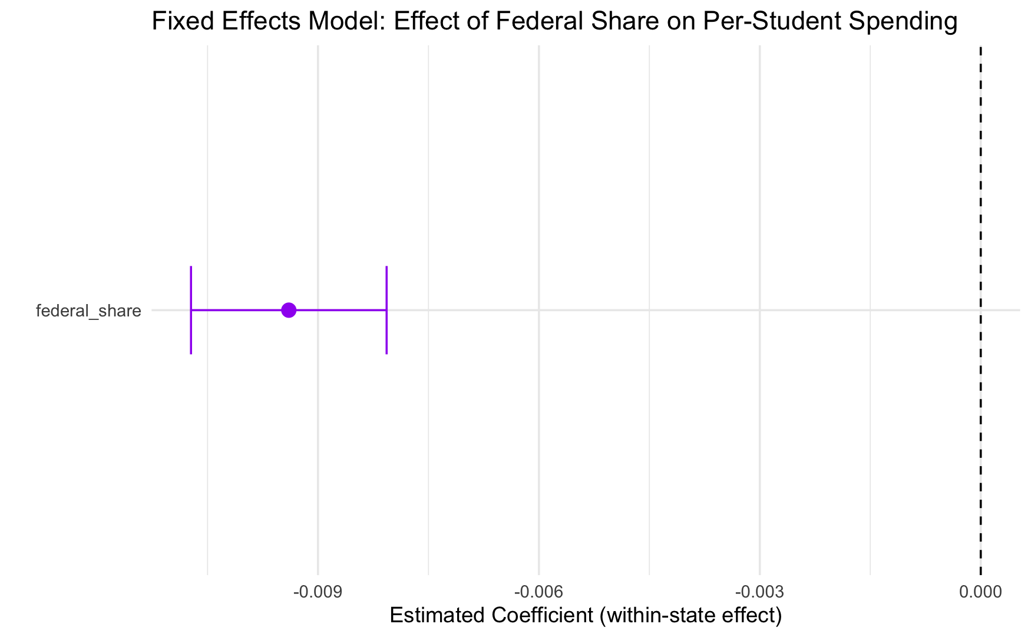
Figure 8. Effect of Federal Share on Per-Student Spending
In this specification, federal share remained negative and highly statistically significant (β = −0.0094, p < 2 × 10⁻¹⁶). While the magnitude of the coefficient is smaller than in the pooled models, this attenuation is expected after removing between-state variation and focusing on within-state changes over time. The result indicates that increases in federal reliance within a given state are associated with reductions in that state’s total per-student spending.
The fixed-effects model achieved a substantially higher explanatory power (adjusted R² = 0.94), reflecting the importance of controlling for persistent state-level differences. Year fixed effects revealed significant post-2008 and post-2020 increases in per-student spending, consistent with recession-related stabilization funding and pandemic-era federal interventions.

Overview
Using state-level education finance data from 2000–2022, this project replicated and extended patterns reported by the National Center for Education Statistics (NCES) to examine how federal funding relates to total per-student education spending. Across exploratory analysis, frequentist regression, Bayesian regression, and a fixed-effects panel model, the results consistently show a negative association between federal revenue share and total per-student spending.
Frequentist regression results indicated that higher federal share is significantly associated with lower per-student spending, even after controlling for year. Bayesian regression produced nearly identical estimates, with narrow credible intervals that excluded zero, providing strong evidence that this relationship is robust. When state fixed effects were introduced, the magnitude of the federal share coefficient decreased but remained statistically significant, indicating that the relationship persists even within states over time after accounting for unobserved, time-invariant state characteristics.
Importantly, these findings do not imply that federal funding reduces education spending. Instead, they reflect structural fiscal inequality: federal funds comprise a larger share of education revenue in states with limited state and local funding capacity. Federal aid appears to play a compensatory role, partially offsetting—but not eliminating—longstanding disparities in education finance across states.

VI. Limitations & Next Steps
Limitations
This analysis has several important limitations that should be considered when interpreting the results. First, while per-student spending is a meaningful indicator of education investment, it is not a direct measure of student outcomes such as academic achievement, graduation rates, or long-term attainment. As a result, the analysis captures differences in financial inputs rather than educational effectiveness or success.
Second, although the dataset spans over two decades and includes all U.S. states and select territories, the structure of the data introduces methodological constraints. The observations form an unbalanced panel with repeated measurements by state over time, which violates the assumption of independent observations used in simple regression models. While a fixed-effects panel model was included to address this issue, more advanced longitudinal techniques—such as dynamic panel models—were beyond the scope of this course.
Third, the analysis relies on aggregate, state-level data, which masks within-state variation. Differences in district wealth, cost of living, student demographics, and policy environments are not directly accounted for, and these factors likely play a substantial role in shaping education spending patterns. Additionally, some data irregularities (such as early-year reporting inconsistencies) required cleaning and exclusion, which may affect year-to-year comparisons.
Finally, the analysis is observational and descriptive in nature. Although statistically significant relationships were identified, the results do not support causal claims about the impact of federal funding on education spending.

Next Steps
Future research could build on this project in several important ways. One natural extension would be to link education finance data with direct student outcome measures, such as standardized test scores, graduation rates, or postsecondary enrollment, to evaluate whether federal funding influences educational performance rather than spending alone. Methodologically, future work could fully adopt panel-data approaches, including random-effects models or difference-in-differences designs, to better isolate within-state changes and policy-driven shifts in federal funding. Incorporating inflation-adjusted dollars, regional cost-of-living indices, and demographic controls would also improve the precision and interpretability of the estimates.
Finally, expanding the analysis to the district level would allow for a more granular examination of inequality in education finance and provide clearer insight into how federal funds interact with local funding capacity. Together, these next steps would move the analysis from descriptive replication toward causal inference and policy evaluation.

VII. Appendix
- Brookings – How Federal Investments in Education Research Help Students Succeed
Wong, V. C., Tipton, E., & Spybrook, J. (2025, April 10). How federal investments in education research help students succeed. Brookings Institution. https://www.brookings.edu/articles/how-federal-investments-in-education-research-help-students-succeed/
- Education Commission of the States – 50-State Comparison (Archive)
Fischer, A., Duncombe, C., & Syverson, E. (2021). 50-State comparison: K-12 and special education funding 2021 (archive). Education Commission of the States. https://www.ecs.org/50-state-comparison-k-12-and-special-education-funding-2021-archive/
- NCES – Public School Revenue Sources
National Center for Education Statistics. (2024). Public school revenue sources. U.S. Department of Education, Institute of Education Sciences. Retrieved from https://nces.ed.gov/programs/coe/indicator/
- U.S. Department of Education – Federal Role in Education
U.S. Department of Education. (2025, June 17). Federal role in education. https://www.ed.gov/about/ed-overview/federal-role-in-education

